**Smart SDLC - AI Enhanced Software Development Lifecycle**

Revolutionizing Software Development with Artificial Intelligence

**Student Details**

**Student Name:** Hema Sundar Sai Ratnala

**Register no:** 22MQ1A4243

**Team Id** : LTVIP2025TMID32757

**Institution:** Sri Vasavi Institute of Engineering and Technology

**Submission Date**: 26 June 2025

**Technology Stack:** Python | IBM Granite | Gradio | LangChain

# **Abstract**

The Smart SDLC (Software Development Life Cycle) project represents a groundbreaking approach to modern software development by integrating artificial intelligence throughout the entire development process. This innovative system leverages IBM's Granite 3.3-2B language model, combined with LangChain and Gradio frameworks, to automate and enhance critical SDLC phases including requirement analysis, code generation, testing, debugging, and documentation.

The application addresses the growing complexity of software development by providing intelligent automation tools that reduce development time, minimize human errors, and improve code quality. Key features include multilingual code generation, automated test case creation, intelligent bug detection and fixing, real-time documentation generation, and seamless GitHub integration. The system also incorporates an Al-powered chatbot for developer assistance and a comprehensive feedback collection mechanism.

This project demonstrates the potential of Al-enhanced development workflows, offering a scalable solution that can significantly improve productivity and code quality in both academic and professional software development environments. The integration of cutting-edge AI technologies with traditional SDLC methodologies creates a powerful platform that bridges the gap between human creativity and machine efficiency.

# **Table of Contents**

1. Introduction 3
   * 1.1 Objective of the Project
   * 1.2 Problem Statement
   * 1.3 Proposed Solution
2. Technology Stack 4
   * 2.1 Core Technologies
   * 2.2 AI and ML Components
   * 2.3 Integration APIs
3. Modules and Features 4
   * 3.1 Al-Powered Requirement Analysis
   * 3.2 Multilingual Code Generation
   * 3.3 Automated Test Case Generation
   * 3.4 Bug Detection & Fixing
   * 3.5 Code Documentation Generator
   * 3.6 AI Chatbot for Developer Queries
   * 3.7 Feedback Collection System
   * 3.8 GitHub Integration
4. System Architecture 6
   * 4.1 Overall System Design
   * 4.2 Component Interaction Flow
   * 4.3 AI Model Integration
5. Implementation 7
   * 5.1 Core Development Approach
   * 5.2 Key Implementation Details
   * 5.3 Technical Challenges and Solutions
6. Conclusion 8
   * 6.1 Project Impact
   * 6.2 Key Learnings
   * 6.3 Future Scope

## **Introduction**

#### **Objective of the Project**

The Smart SDLC project aims to revolutionize traditional software development practices by integrating artificial intelligence at every stage of the Software Development Life Cycle. The primary objective is to create an intelligent, automated system that can assist developers in requirement analysis, code generation, testing, debugging, and documentation while maintaining high standards of code quality and development efficiency.

* 1. **Problem Statement**

Modern software development faces several critical challenges:

* + - Time-Intensive Processes: Traditional SDLC phases require significant manual effort and time investment
    - Human Error Susceptibility: Manual coding and testing processes are prone to errors and inconsistencies
    - Repetitive Task Overhead: Developers spend considerable time on routine tasks like documentation and basic code generation
    - Quality Assurance Gaps: Inconsistent testing and review processes can lead to bugs in production
    - Knowledge Gaps: Junior developers often struggle with best practices and optimal coding patterns
    - Integration Complexities: Managing multiple tools and platforms creates workflow inefficiencies

#### **Proposed Solution**

Smart SDLC addresses these challenges through an Al-enhanced development platform that provides:

* + - **Intelligent Automation:** Al-powered tools for requirement analysis, code generation, and testing
    - **Quality Assurance:** Automated bug detection and fixing capabilities using advanced language models
    - **Developer Assistance:** Real-time AI chatbot support for technical queries and best practices
    - **Seamless Integration:** Built-in GitHub integration for version control and collaboration
    - **Comprehensive Documentation:** Automated generation of technical documentation and project reports
    - User-Centric Design: Intuitive Gradio-based interface accessible to developers of all skill levels

## **Technology Stack**

###### **Core Technologies**

Python 3.8+: Primary programming language chosen for its extensive AI/MLlibraries, rapid development capabilities, and strong community support in the artificial intelligence domain.

**Gradio:** Modern web framework for creating intuitive user interfaces for machine learning applications, providing seamless interaction between users and AI models.

* 1. AI and ML Components

**IBM Granite 3.3-2B Instruct Model:** State-of-the-art large language model specifically designed for code generation, analysis, and technical documentation. This model provides exceptional performance in understanding programming contexts and generating human-like responses.

**LangChain:** Powerful framework for developing applications with large language models, enabling complex workflows, memory management, and chain-of-thought reasoning capabilities.

**Hugging Face Transformers:** Integration platform for accessing and deploying pre-trained language models with optimized inference capabilities.

### **Integration APIs**

**GitHub API:** Enables seamless integration with version control systems, allowing automated repository management, pull request creation, and collaborative development workflows.

**IBM Watsonx:** Enterprise-grade AI platform providing secure and scalable access to foundation models with enterprise-level governance and compliance features.

# **Modules and Features**

### AI-Powered Requirement Analysis

The requirement analysis module leverages natural language processing to transform user requirements into structured, actionable development tasks. The system analyzes input requirements, identifies key functionalities, suggests optimal implementation approaches, and generates comprehensive project specifications.

Key Features:

* Natural language requirement parsing
* Automated user story generation
* Technical specification creation
* Risk assessment and mitigation suggestions

### **Multilingual Code Generation**

This module provides intelligent code generation capabilities across multiple programming languages including Python, JavaScript, Java, C++, and more. The AI model understands context, follows best

practices, and generates production-ready code snippets based on natural language descriptions. Key Features:

* + - Multi-language support (Python, JavaScript, Java, C+ +, Go, Rust)
    - Context-aware code generation
    - Best practice adherence
    - Code optimization suggestions

##### **Automated Test Case Generation**

The testing module automatically generates comprehensive test cases based on the generated code or existing codebase. It creates unit tests, integration tests, and edge case scenarios to ensure thorough code coverage and robust application behavior.

Key Features:

* + - Unit test generation
    - Integration test creation
    - Edge case identification
    - Test coverage analysis

##### **Bug Detection & Fixing**

This intelligent debugging module analyzes code for potential bugs, security vulnerabilities, and performance issues. It not only identifies problems but also provides automated fixes and suggestions for code improvements.

Key Features:

* + - Static code analysis
    - Security vulnerability detection
    - Performance bottleneck identification
    - Automated bug fixing suggestions
  1. Code Documentation Generator

The documentation module automatically generates comprehensive technical documentation including API documentation, code comments, README files, and user manuals based on the codebase analysis.

Key Features:

* + - API documentation generation
    - Inline code commenting
    - README file creation
    - User manual generation
  1. **AI Chatbot for Developer** **Queries**

An intelligent chatbot assistant provides real-time support for developer queries, coding best practices, debugging assistance, and technical guidance throughout the development process.

Key Features:

* + - Real-time query resolution
    - Best practice guidance
    - Debugging assistance
    - Technology recommendations

##### **Feedback Collection System**

A comprehensive feedback mechanism that collects user inputs, analyzes development patterns, and continuously improves the AI model's performance based on real-world usage data.

Key Features:

* + - User feedback collection
    - Performance analytics
    - Model improvement suggestions
    - Usage pattern analysis

##### **GitHub Integration**

Seamless integration with GitHub repositories enabling automated code commits, pull request creation, branch management, and collaborative development workflows.

Key Features:

* Repository management
* Automated commits and pull requests
* Branch synchronization
* Collaborative workflow support

## **System Architecture**

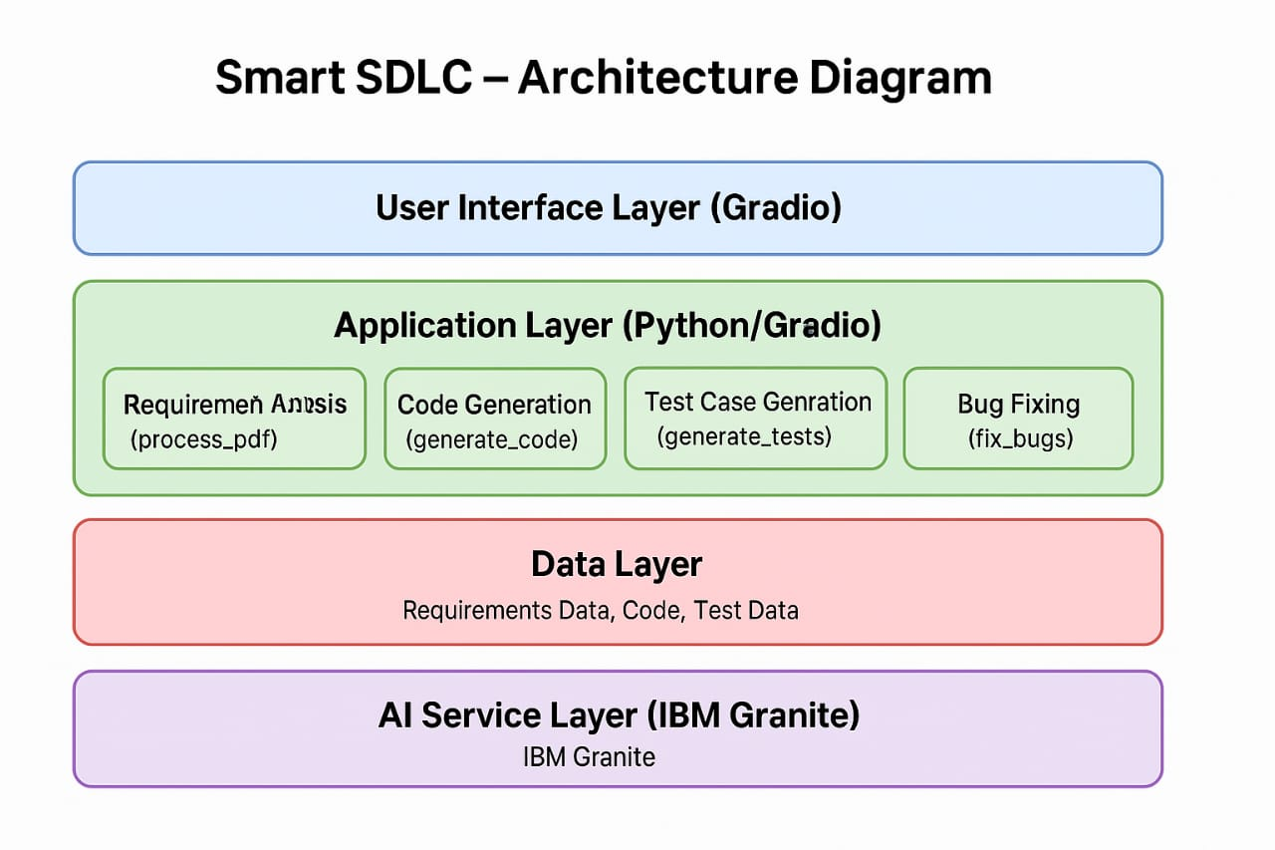

##### **Overall System Design**

The Smart SDLC system follows a modular microservices architecture that ensures scalability, maintainability, and seamless integration between different components. The architecture consists of three primary layers:

Presentation Layer: Gradio-based web interface providing intuitive user interaction Business Logic Layer: Core AI processing modules and workflow management Data Layer: Model storage, user data management, and GitHub integration

#### **Component Interaction Flow**

The system workflow follows these key phases:

1. Model Selection and Architecture (Milestone 1)
   * Research and select appropriate AI models
   * Define system architecture
   * Set up development environment
2. Core Functionalities Development (Milestone 2)
   * Implement core Al-powered features
   * Integrate FastAPl backend for smooth API interactions
   * Develop routing and user input processing
3. Main Application Logic (Milestone 3)
   * Write main application logic in Main.py
   * Integrate all modules and components
   * Implement error handling and validation
4. Frontend Development (Milestone 4)
   * Design and develop user interface
   * Create dynamic interaction with backend
   * Implement responsive design principles
5. Deployment (Milestone 5)
   * Prepare application for local deployment
   * Test and verify local deployment functionality
   * Optimize performance and resource usage
6. Conclusion and Documentation (Milestone 6)
   * Finalize project documentation
   * Conduct comprehensive testing
   * Prepare deployment packages
   1. AI Model Integration

The IBM Granite model is integrated through a sophisticated pipeline that handles:

* + - Input preprocessing and tokenization
    - Context management and conversation history
    - Response generation and post-processing
    - Model fine-tuning based on user feedback

1. **Implementation**
   1. **Core Development Approach**

The implementation follows an agile development methodology with iterative milestones, ensuring continuous integration and testing throughout the development process. The project structure emphasizes modularity, allowing for independent development and testing of individual components.

##### **Technical Challenges and Solutions**

Challenge 1: Model Performance Optimization

* + - Solution: Implemented efficient caching mechanisms and request batching to improve response times

Challenge 2: Multi-language Code Generation

* + - Solution: Created context-aware prompts and fine-tuned model parameters for different programming languages

Challenge 3: GitHub Integration Complexity

* + - Solution: Developed robust API wrapper with error handling and retry mechanisms

1. **Conclusion**

##### **Project Impact**

The Smart SDLC project demonstrates the transformative potential of AI in software development. By automating routine tasks and providing intelligent assistance, the system can significantly reduce development time, improve code quality, and lower the barrier to entry for new developers. The project showcases practical applications of large language models in real-world development scenarios.

### **Key Learnings**

Throughout this project, several valuable insights were gained:

* + - **AI Integration Complexity:** Understanding the nuances of integrating large lanpuape models into production applications
    - User Experience Design: Balancing powerful AI capabilities with intuitive user interfaces
    - **Scalability Considerations:** Designing systems that can handle varying loads and user requirements
    - Quality Assurance: Implementing robust testing and validation mechanisms for Al-generated content

#### **Future Scope**

The Smart SDLC project provides a foundation for numerous future enhancements: Advanced AI Capabilities:

* + - Integration with more specialized models for different programming domains
    - Implementation of reinforcement learning for continuous improvement
    - Advanced code analysis using graph neural networks

Enterprise Features:

* + - Multi-tenant architecture for team collaboration
    - Advanced security and compliance features
    - Integration with popular development tools and IDEs Extended Platform Support:
    - Mobile application development
    - Cloud deployment automation
    - DevOps pipeline integration Enhanced User Experience:
    - Voice-activated coding assistance
    - Visual code generation through drag-and-drop interfaces
    - Personalized AI assistants based on developer preferences

The project represents a significant step toward the future of Al-assisted software development, where human creativity is amplified by intelligent automation, creating more efficient, reliable, and innovative software solutions.

**